**Java Web Lab1-Jdbc**

Prajwal_77

Q1. Create a table Student with following fields.  
1. studID  
2. Name  
3. Course  
4. totMark  
5 grade

*package* assignment1;  
*/*  
  
Create a table Student with following fields.  
 1. studID  
 2. Name  
 3. Course  
 4. totMark  
 5 grade  
  
*/  
import* java.sql.*Connection*;  
*import* java.sql.DriverManager;  
*import* java.sql.SQLException;  
*import* java.sql.*Statement*;  
  
*public class* abc {  
 *public static void* main(String[] args) *throws* SQLException, ClassNotFoundException {  
 Class.*forName*("com.mysql.cj.jdbc.Driver");  
 *Connection* con = DriverManager.*getConnection*("jdbc:mysql://localhost:3306/java", "root", "Prajwal@123");  
 *Statement* s = con.createStatement();  
 *// execute query* s.execute("create table students (studID int primary key,Name varchar(20),Course varchar(50),totMark float(5,2),grade varchar(20))");  
 *//s.execute("create table student(studID int primary key,name varchar(20),Course varchar(50),marks float(5,2))");* System.***out***.println("Table successfully Created");  
 s.close();  
 *// close connection* con.close();  
  
 }  
  
}

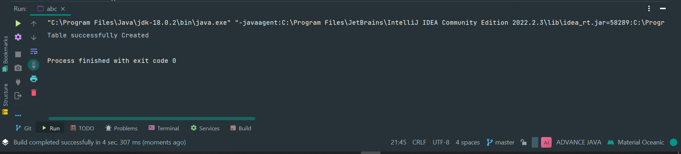

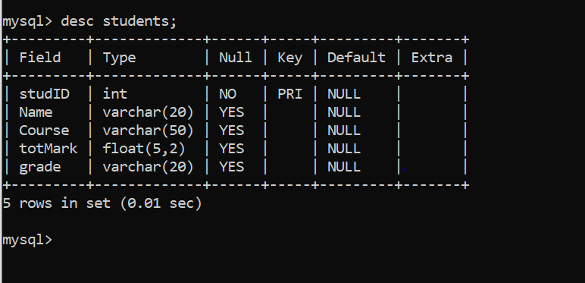

**Write a Menu driven program with following menus  
1. insert  
2. show a Student  
3. update a student  
4. delete a student  
5. show all students  
6. exit  
  
Take input values from user and perform the tasks**

*package* Nov15;  
  
*import* java.sql.*Connection*;  
*import* java.sql.DriverManager;  
*import* java.sql.*ResultSet*;  
*import* java.sql.SQLException;  
*import* java.sql.*Statement*;  
*import* java.util.Scanner;  
  
*public class* JDBC_Lab1 {  
 *public static void* main(String[] args) {  
 Scanner sc = *new* Scanner(System.***in***);  
 *try* {  
 Class.*forName*("com.mysql.cj.jdbc.Driver");  
 *Connection* con = DriverManager.*getConnection*("jdbc:mysql://localhost:3306/java", "root", "Prajwal@123");  
 *Statement* s = con.createStatement();  
  
 String query = ("create table Student(stdid int primary key,Name varchar(20),Course varchar(20),totMark float(4,2),grade varchar(10))");  
 *//s.executeUpdate(query);* System.***out***.println("Student Table Created Successfully");  
 *int* opt=1;  
 *while*(opt!=0) {  
 System.***out***.println("\nMenu");  
 System.***out***.println("1. Insert");  
 System.***out***.println("2. Show a Student");  
 System.***out***.println("3. Update a Student");  
 System.***out***.println("4. Delete a student");  
 System.***out***.println("5. Show all students");  
 System.***out***.println("6. Exit");  
 System.***out***.println("Enter your Option: ");  
 opt = sc.nextInt();  
 *switch*(opt) {  
 *case* 1:  
 System.***out***.println("Enter Student-ID: ");  
 *int* id = sc.nextInt();  
 System.***out***.println("Enter Name: ");  
 String name = sc.next();  
 System.***out***.println("Enter Course: ");  
 String course = sc.next();  
 System.***out***.println("Enter Marks: ");  
 *float* marks = sc.nextFloat();  
 System.***out***.println("Enter Grade: ");  
 String grade = sc.next();  
   
 query = ("\ninsert into Student values("+id+",'"+name+"','"+course+"','"+marks+"','"+grade+"')");  
 *//query = "insert into student values("+id+",'"+name+"','"+course+"',"+marks+",'"+grade+")";* System.***out***.println(query);  
 *int* i = s.executeUpdate(query);  
 System.***out***.println(i+" row inserted");  
 *break*;  
   
 *case* 2:  
 System.***out***.println("Enter Student-ID: ");  
 id = sc.nextInt();  
 query = ("\nselect * from Student where stdid = "+id);  
 System.***out***.println(query);  
 *ResultSet* rs = s.executeQuery(query);  
 *while*(rs.next()) {  
 System.***out***.println(rs.getInt(1)+" "+rs.getString(2)+" "+rs.getString(3)+" "+rs.getFloat(4)+" "+rs.getString(5));   
   
 }  
 *break*;  
   
 *case* 3:  
 System.***out***.println("Enter Student-ID: ");  
 id = sc.nextInt();  
 System.***out***.println("Enter Name: ");  
 name = sc.next();  
 System.***out***.println("Enter Course: ");  
 course = sc.next();   
 query = "\nupdate Student set Name = '"+name+"',Course = '"+course+"'where stdid = "+id;  
 System.***out***.println(query);  
 *int* j = s.executeUpdate(query);  
 System.***out***.println(j+" row updated");  
 *break*;  
   
 *case* 4:  
 System.***out***.println("Enter Student-ID: ");  
 id = sc.nextInt();   
 query = "\ndelete from Student where stdid = "+id;  
 System.***out***.println(query);  
 *int* k = s.executeUpdate(query);  
 System.***out***.println(k+" row deleted");  
 *break*;  
   
 *case* 5:  
 query = "\nselect * from Student";  
 System.***out***.println(query);  
 *ResultSet* rst = s.executeQuery(query);  
 *while*(rst.next()) {  
 System.***out***.println(rst.getInt(1)+" "+rst.getString(2)+" "+rst.getString(3)+" "+rst.getFloat(4)+" "+rst.getString(5));   
   
 }  
 *break*;  
   
 *case* 6:  
 System.***out***.println("Bye");  
 System.*exit*(0);  
   
 *default*:  
 System.***out***.println("Illegal Options taken");   
 }  
 }  
 }*catch*(ClassNotFoundException | SQLException e) {  
 e.printStackTrace();  
 }  
 }  
}

**OUTPUT-**

"C:\Program Files\Java\jdk-18.0.2\bin\java.exe" "-javaagent:C:\Program Files\JetBrains\IntelliJ IDEA Community Edition 2022.2.3\lib\idea_rt.jar=54096:C:\Program Files\JetBrains\IntelliJ IDEA Community Edition 2022.2.3\bin" -Dfile.encoding=UTF-8 -Dsun.stdout.encoding=UTF-8 -Dsun.stderr.encoding=UTF-8 -classpath "D:\CORE JAVA\DAY6\ADVANCE JAVA\out\production\ADVANCE JAVA;C:\Users\prajw\Downloads\mysql-connector-j-8.0.31\mysql-connector-j-8.0.31.jar" Nov15.JDBC_Lab1

Student Table Created Successfully

Menu

1. Insert

2. Show a Student

3. Update a Student

4. Delete a student

5. Show all students

6. Exit

Enter your Option:

1

Enter Student-ID:

10

Enter Name:

spiderman

Enter Course:

PGDAC

Enter Marks:

95

Enter Grade:

A

insert into Student values(10,'spiderman','PGDAC','95.0','A')

1 row inserted

Menu

1. Insert

2. Show a Student

3. Update a Student

4. Delete a student

5. Show all students

6. Exit

Enter your Option:

2

Enter Student-ID:

10

select * from Student where stdid = 10

10 spiderman PGDAC 95.0 A

Menu

1. Insert

2. Show a Student

3. Update a Student

4. Delete a student

5. Show all students

6. Exit

Enter your Option:

3

Enter Student-ID:

10

Enter Name:

Elon musk

Enter Course:

update Student set Name = 'Elon',Course = 'musk'where stdid = 10

1 row updated

Menu

1. Insert

2. Show a Student

3. Update a Student

4. Delete a student

5. Show all students

6. Exit

Enter your Option:

1

Enter Student-ID:

20

Enter Name:

Ananad Mahindra

Enter Course:

Enter Marks:

88

Enter Grade:

A

insert into Student values(20,'Ananad','Mahindra','88.0','A')

1 row inserted

Menu

1. Insert

2. Show a Student

3. Update a Student

4. Delete a student

5. Show all students

6. Exit

Enter your Option:

4

Enter Student-ID:

20

delete from Student where stdid = 20

1 row deleted

Menu

1. Insert

2. Show a Student

3. Update a Student

4. Delete a student

5. Show all students

6. Exit

Enter your Option:

5

select * from Student

10 Elon musk 95.0 A

Menu

1. Insert

2. Show a Student

3. Update a Student

4. Delete a student

5. Show all students

6. Exit

Enter your Option:

**SQL TABLE FINAL OUTPUT -**

